Reability Architecture

General
The Reability project has 4 major parts:
1. Main app - Client Side written in Angular
2. Main app – Server Side NodeJS server connected to PostgresSQL DB.
3. Peer JS Service – NodeJS service that transfers messages from patients to therapists
4. Games – Client Side written in various of web technologies and are hosted in the main app as an iFrame.
Every game has an sdk.js file that is supplied by one-digital to allow the game to communicate with the “outside world” meaning the main app.
Main App Functionality
The main functionality is implemented according to the login user’s role.
There are 3 roles in the system.
1. Patient
2. Therapist
3. Admin

Patient
The patient is a person who has some difficulties in some basic daily actions and needs a rehabilitation treatment.
The patient uses the system to play games according to its needs.

Every game is hosted in an iFrame that communicates with the main app via the sdk file that one-digital supplies.
The main app uses a movement tracking system that identify the position of every organ of the patient using the regular web camera in the patient’s computer.
We use Media Pipe pose solution for this:
https://google.github.io/mediapipe/solutions/pose

When the patient moves one of its organs, the main app get the current coordinates from the posnet component and transfers them to the iFrame and also sends them to the therapist side (if therapist is connected).

Therapist
The therapist can make a video call to the logged-in patient and perform a session.
The therapist can control the patient’s app by starting/ending a game,
change game settings , switch to full screen view (for a personal talk) and even share its screen to the patient.
When the patient moves, the therapist can see a group of dots that shows the movement of the patient’s organs so he/she is able to decide the status of improvement of the patient.

The system supports up to 4 sessions at the same time, so the therapist can switch from one patient to the other during a single session.

In addition, the therapist can setup its availability for treatments , so the system admin can schedule treatments for him/her when available.

Admin
The admin manages all data in the system.
It creates patients and therapists and sets the patients treatment plans.
It also have a followup-system that allows him/her to set reminders for a specific days to make actions (like call a patient in a specific time).

The admin has the ability to manage all treatments schedule according to the availability of the therapist and the patient.

The system supports multiple health centers (called institutes)
Every therapist and patient are connected to several departments in an institute, so every therapist sees only the patients that are related to the same departments as his/hers.

Games
The system supports the following games :
1. Memory – the patient needs to select identical cards to get a point developed by one digital in Angular
2. Squat – the patient sees a video of squat exercise and tries to do the same, the system tracks its movement and set a score according.
developed by one digital in Angular
3. KP – the patient needs to put its hand on an object to get a score
developed by external developer (Anat Cohen) in Phaser framework.
4. Puzzle – The patient needs to catch a moving object (part of a puzzle) and by catching it the object is added to the puzzle parts.
developed by external developer (Anat Cohen) in Phaser framework.
5.Marina – The patient needs to move boats in all directions to allow the main boat to cross a path.
developed by external developer (Anat Cohen) in Phaser framework.
6. Studio – The patient sees a collection of videos , demonstrating exercises that he/she needs to perform .
The therapist selects the list of videos according to the needed treatment and the patient’s language.
During a session, the therapist can control the videos (play/pause/move to another video)…
developed by one digital in Angular.

7. Xonix – the patient has to conquer as much territory as possible while avoiding the characters who will try to disturb him/her.
In development by external developer (Anat Cohen) in Phaser framework.
8. Voice – this is for mainly patients with Parkinson.
The game has a text area where both patient and therapist can write and a voice area that measures the level of voice of the patient.
This game is in development by “Medix” company and is developed in React.
9. Wipe – The patient needs to use its hands to wipe (clean) a “dirty” window to expose a whole image under it.
This game is developed by one-digital in Angular.

Architecture

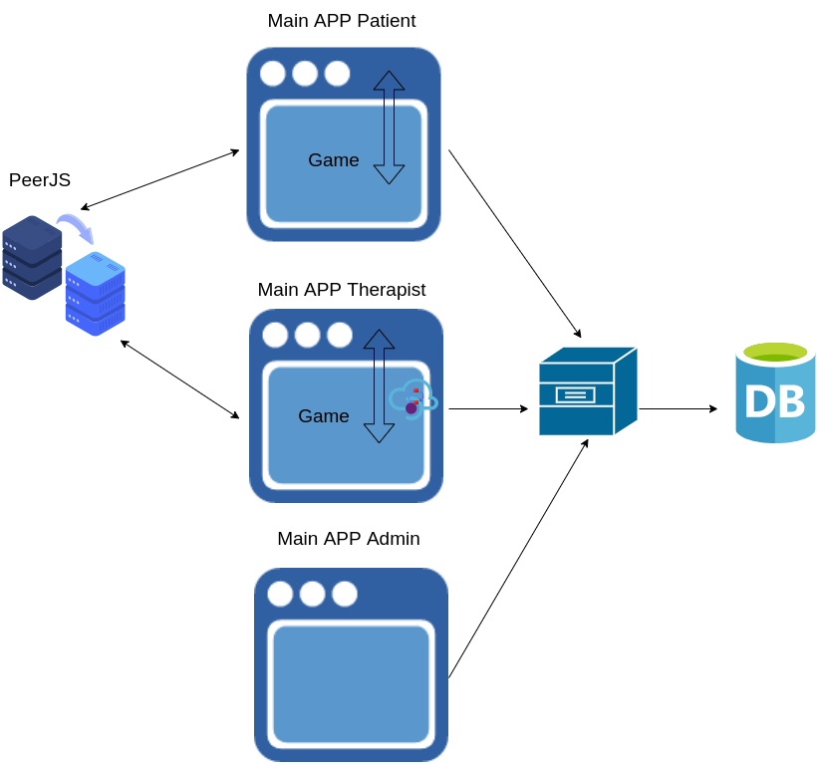

Missing Functionality
1. The system only supports one admin and there is no way to add another one, we need to enable this feature but also divide the admins according to institutes.

2. Currently every game has capability to save a summary of a game session (like the game score for example).
There is no UI that shows these summaries or a graph that can show the patient progress.

3. Today we have a few games , but if we expand we need to make categories for them according to the patient treatment.
This will help us to decide which games to show for every patient.
(currently all patients sees all games)

4. We have an infrastructure in the studio game that allows to configure (hard-coded in json file) for every video, the movement that the patient needs to do in order to get a score.
We have made this as a pilot of one of the videos.
Currently we supoort only several organs.
We need to expand it and create a videos system configuration screen.

